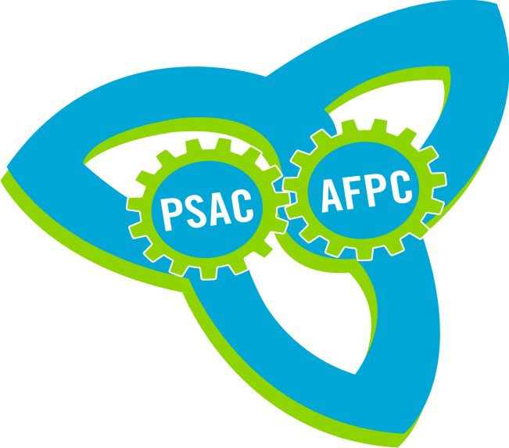

PSAC ONTARIO REGION

COMMITTEE FUNDING &
REPORTING PROCEDURES

October 2013

ONTARIO REGION COMMITTEES

Within the Ontario Region, PSAC activists participate in a variety of committees, including the following currently established committees:

- Toronto Area Council, Toronto Regional Women’s Committee, Pride Committee, Racially Visible Committee, Aboriginal Circle, Members with Disabilities Action Committee
- Durham Regional Women’s Committee
- Hamilton Area Council, Hamilton Regional Women’s Committee, Members with Disabilities Action Committee
- Niagara Area Council
- Barrie Area Council, Barrie Regional Women’s Committee
- London Area Council, London Regional Women’s Committee
- Kitchener-Waterloo Area Council, Kitchener-Waterloo Regional Women’s Committee
- Windsor Area Council, Windsor Regional Women’s Committee
- Kingston Area Council, Kingston Regional Women’s Committee
- Sudbury Area Council, Sudbury Regional Women’s Committee
- Northeastern Area Council
- Thunder Bay Area Council, Thunder Bay Regional Women’s Committee, Thunder Bay Aboriginal Circle

As a result of the resolution passed at the 2012 PSAC National Triennial Convention, the opportunity now exists for members to establish Young Workers Committees.

With 18 active committees in the region and 11 active Area Councils, a consistent approach to the reporting and operation of area councils and committees is necessary to be efficient, transparent and accountable for funds received from PSAC regionally and nationally.

FUNDING
Committees receive funds from two primary sources: PSAC Ontario Region as provided for in the budget approved at the PSAC Ontario Regional Triennial Convention and PSAC National as provided for in the budget approved by delegates to the PSAC National Triennial Convention.

*For the purpose of these procedures and accompanying documents, the term “committee” refers to all Ontario committees including Area Councils, Regional Women’s Committees, Human Rights Committees, Aboriginal Circles and future Young Workers Committees.
YEAR-END REPORTING
At the end of each calendar year, each committee is required to submit documentation to the REVP's office. In order to be considered a committee in good standing and to receive funding, committees are required to submit the following:

- Cover Sheet (using the template in Appendix A)
- Contact information for executive members (using the template in Appendix B)
- Financial statement (using the Excel template provided)
- Copies of each monthly bank statement for January through December
- Minutes of each meeting held for the calendar year. To be considered a committee in good standing, committees must hold a minimum of four meetings per year, as per Section 15, Sub-Section (4) of the PSAC Constitution.
- Completed audit report form (using the template in Appendix C)
- Budget for new year (using the Excel template provided)

Prior to submitting the information to the REVP, the committee must have their financial records audited by members. Procedures for the audit and reporting of findings to follow.

Once all documentation is compiled, it is to be submitted to the REVP’s office. A copy of all documentation should also be sent to the appropriate Ontario Regional Council Representative (ORC) - listed below.

- Area Councils submit to their respective ORC rep.
- All RWC’s submit to the ORC RWC rep.
- Human Rights Committees
  - For equity specific committees, records should be submitted to the appropriate ORC.
- Young Workers Committees, when established, submit to the ORC Young Workers rep.

All submissions must be received in the REVP's office no later than March 15 of each year. Committees who have not submitted all the information prior to the deadline will not receive any funding for the calendar year.

Committees not requiring additional funds for the year are still required to submit all documentation and a budget indicating they are not requesting additional funds.

AUDITING FINANCIAL RECORDS

At the end of the year, after the committee treasurer has completed the annual financial statement, the records must be audited by a minimum of two members. To ensure transparency, members who are not executive members of the committee should complete the audit.

Documents required before starting the audit:

- Committee Bylaws (mandatory for Area Councils – other committees may have Bylaws or Terms of Reference)
- Original Bank Statements
- Original Cheque Register/Stubs
- Copies of all meeting minutes
- Annual Financial Statement prepared by the committee treasurer

Process to Audit Records

- Using the bank statements, ensure the opening balance on the Financial Statements matches the bank balance.

- Reconcile each bank statement by ensuring that all cheques are accounted for. The cheque register should be reviewed to ensure that any voided cheques are available and to identify any stale-dated or outstanding cheques.

- Every transaction on the bank statement must have supporting documentation. Auditors should check meeting minutes to ensure that all expenses over $100 (unless otherwise specified in the Bylaws or Terms of Reference) are identified as approved in the minutes. Approval can be by vote or by consensus. Any expenses exceeding $100 that are not approved at a committee meeting must be noted on the audit report.

- Ensure the ending balance on the financial statement matches the ending balance on the bank statement.

- Any irregularities that cannot be reconciled or appear as fraudulent must be reported to the REVP’s office immediately.

- Once completed, the auditors should complete the audit report form (Appendix C) and return the form and records to the committee treasurer.

Appendix A

COMMITTEE ANNUAL REPORT COVER SHEET

COMMITTEE: ______________________________________

LOCATION: ______________________________________

Have you attached the following documentation?

- List of committee executive contact information (Appendix B)

- Minutes of all meetings

- Copies of bank statements for January through December

- Completed audit report (Appendix C)

- Annual financial statement (using the Excel template provided)

- Budget request (using the Excel template provided)

DATE SUBMITTED TO ORC REP: ___________________________

ORC REP:

Submission has been reviewed and all applicable information is attached.

______________________________ _______________________
Signature of ORC rep Date

REVP OFFICE:

Date Received: ________________________

Appendix B

COMMITTEE EXECUTIVE CONTACT INFORMATION

COMMITTEE: ______________________________________

Position
Name
Mailing Address
Email (not work)
Phone (W) (H) (C)

Position
Name
Mailing Address
Email (not work)
Phone (W) (H) (C)

Position
Name
Mailing Address
Email (not work)
Phone (W) (H) (C)

Position
Name
Mailing Address
Email (not work)
Phone (W) (H) (C)

Appendix C

COMMITTEE AUDIT REPORT

COMMITTEE: ___________________________________

AUDITORS: ___________________________________

___________________________________

We have reviewed the information provided and it is our conclusion that all funds have been properly accounted for and documented.
□ YES □ NO

If No, please describe discrepancies below

Auditors: _______________________ _______________________
Print Name Signature

_______________________ _______________________
Print Name Signature

Date Audit Completed: __________________________

REVP Office

Date Received: __________________________

