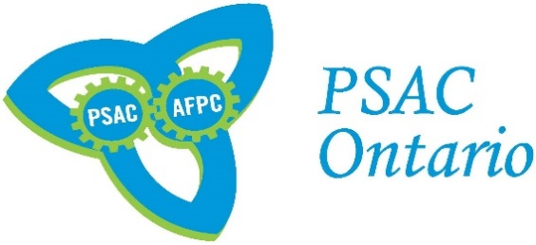**PSAC Ontario Activism Awards**

*Call for Nominations*

Three (3) awards will be presented at this year’s 2020 Ontario Regional Triennial Convention to members who have shown a high level of activism and outstanding contributions to their union. This could be a member’s work on campaigns, notable leadership, years of activism, mobilization efforts, etc.

Please note that Ontario Regional Council members are not entitled to be nominated, however they can nominate other members. Furthermore, members cannot nominate themselves.

Eligibility is based on the following criteria:

* Must be a PSAC Ontario Region member who is in good standing, as of May 1, 2020
* Has shown exemplary leadership and activism on behalf of PSAC Ontario’s membership

**Making a Nomination:**

Any PSAC Ontario region member in good standing, can submit a nomination (limit 1 nomination per member). A nominator does not require a seconder, but must provide the following information:

* A 500-word (maximum) explanation on how the nominated member has shown their exemplary contributions to our union
* The member’s full name, Component/DCL and Local number
* Nominator’s contact information, should we require further information

If you know a PSAC Ontario region activist who you believe meets or exceeds the criteria listed above, you are encouraged to send, in writing (max 500 words), your nomination to Lino Vieira, Political Communications Officer ([vieiral@psac-afpc.com](mailto:vieiral@psac-afpc.com)) no later than **April 8, 2020.**

Please describe the nominee’s achievements, efforts or leadership and how their union activism has positively impacted PSAC and/or the wider Labour Movement.

**Selection:**

The Awards Committee will review all nominations and select the winning recipients. The award recipients will then be notified by the REVP’s office and the award will be presented at the 2020 Ontario Regional Triennial Convention. If the member is not attending the Ontario Regional Triennial Convention, the award will be presented to their Local representative on their behalf, or by the REVP if there is no Local representation.

For more information on the PSAC Ontario Activism Award, please contact Lino Vieira ([vieiral@psac-afpc.com](mailto:vieiral@psac-afpc.com)).