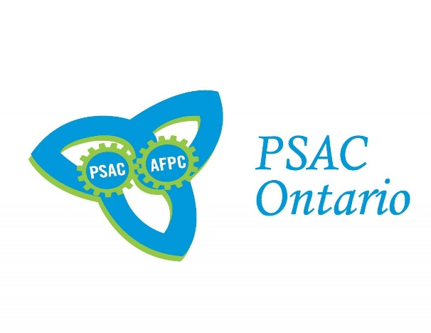 **DCL FINANCIAL PROCEDURES ZOOM MEETING**

**MARCH 10TH, 2021**

2 ZOOM MEETINGS OFFERED

12:00 – 2:00 P.M. & 6:30 – 8:30 P.M.

When: Mar 10, 2021 **12:00 AM -2:00 P.M.** Eastern Time (US and Canada)

Register in advance for this meeting:

https://psac-afpc.zoom.us/meeting/register/u5EqcuGtpzwtGtDf7_auG-rk3D9dUxSxfyIu

****************************************************************

When: Mar 10, 2021 **6:30 – 8:30 PM** Eastern Time (US and Canada)

Register in advance for this meeting:

https://psac-afpc.zoom.us/meeting/register/u5Etd-qrqD4qGtGRe1_DEvZCDOl3MhUTJEZl

After registering, you will receive a confirmation email containing information about joining the meeting.

**Learning Objectives**

* DCL Council Reps
* Treasurer Role and Duties
* Newly Elected Officers
* Bank Account Information
* RC59 Business Consent

Representative

* Understanding PSAC

Membership Lists

* Union Dues
* Financial Checklist
* Reports