SEE YOU FOR A SOLIDARITY LUNCH!!

PSAC LONDON AREA COUNCIL
LABOUR DAY CELEBRATION


DATE: THURSDAY, AUGUST 28, 2014
LOCATION: 451 TALBOT STREET (courtyard)
TIME: noon – 1:15PM

FREE Raffle
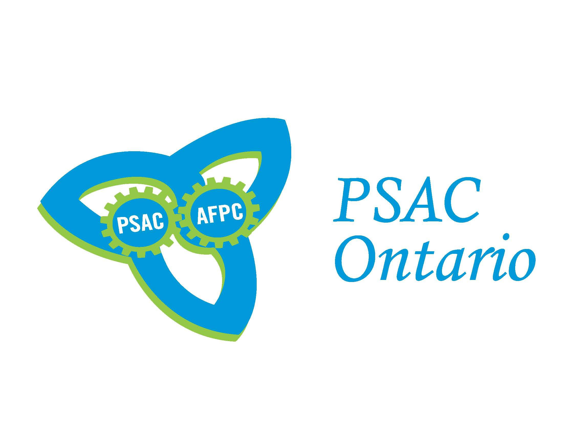

Public Service Alliance of Canada/Alliance de la Fonction publique du Canada

