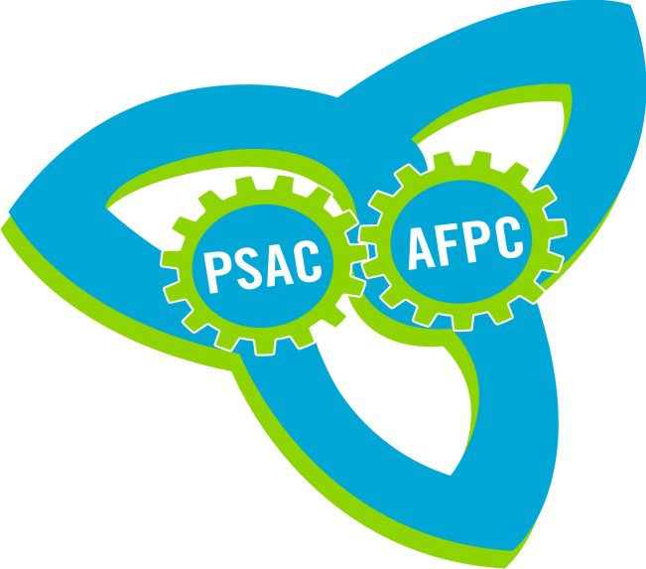  PSAC Ontario | Local Presidents, Component Presidents & Executive and Regional Council Members  REGISTRATION FORM  Meeting to Launch Plan Against Government Attacks |  |  |  |  |  | 
Application form must be faxed or emailed to your closest Regional Office
(see list attached) prior to event.
Regional Office: |  |  |  |  | Location:
Name: |  |  |  |  | Date:
PSAC ID #:
Comp/Local: |  |  |  |  | Position in Local:
Address (home): |  |  | City: |  | Province: | Postal Code:
Address (work): |  |  | City: |  | Province: | Postal Code:
Home Phone: |  |  |  | Work Phone:
Fax: |  |  |  | Email:
SPECIAL NEEDS: E.G. Special diet, wheelchair access, sign language, documents in alternate formats etc.
Self- Identification (Optional) – PLEASE CIRCLE or MARK with “X”
Are you a member of any of these Equity Groups? |  | __ Woman  __ Aboriginal Member  __ Racially Visible Member  __ Member with Disabilities  __ Gay, Lesbian, Bisexual, or Trans Members
Are you a Young Worker? (Age 30 or Under) |  | ____ YES _____ NO
SMOKE FREE: All PSAC events, including this meeting, are smoke free.

SCENT FREE: This meeting is scent free to ensure an environmentally safe space.

STATEMENT ON HARASSMENT: PSAC will not condone or tolerate behaviour which undermines the full and equal participation of all in union activities.

SPECIAL NEEDS – ACCESS REQUIREMENTS: PSAC is committed to ensuring that the accessibility and dietary requirements of our members are respected. Please indicate your needs on the application form and provide any necessary explanation that will assist us in meeting them. PSAC will take the necessary action to ensure the availability of transportation, equipment and/or people required to enable all members to attend and fully participate in this course.

Complete your registration form
and submit to your closest Regional Office

PSAC – Kingston Regional Office
City Place 1, 1471 John Counter Blvd., Suite 412
Kingston, ON K7M 8S8
Phone: 613-542-7322 Fax: 613-542-7387
Toll Free – 1-800-355-0783 Email: LoshakK@psac.com
PSAC – London Regional Office
480 Sovereign Road, U-11
London, ON N6M 1A4
Phone: 519-659-1124 Fax: 519-659-1132
Toll Free – 1-800-366-0539 Email: EatonL@psac.com
PSAC – Thunder Bay Regional Office
Suite 109, 1205 Amber Drive
Thunder Bay, ON P7B 6M4
Phone: 807-345-8442 Fax: 807-344-0704
Toll Free – 1-800-355-0794 Email: GoodicS@psac.com
PSAC – Sudbury Regional Office
Unit 2 – 754 Falconbridge Rd.
Sudbury, ON P3A 5X5
Phone: 705-674-6907 Fax: 705-674-8652
Toll Free – 1-800-354-9134 Email: MannC@psac.com
PSAC – Toronto Regional Office
90 Eglinton Avenue East, Suite 608
Toronto, ON M4P 2Y3
Phone: 416-485-3558 Fax: 416-485-8607
Toll Free – 1-800-354-9086 Email: psac_toronto_mail@psac.com

