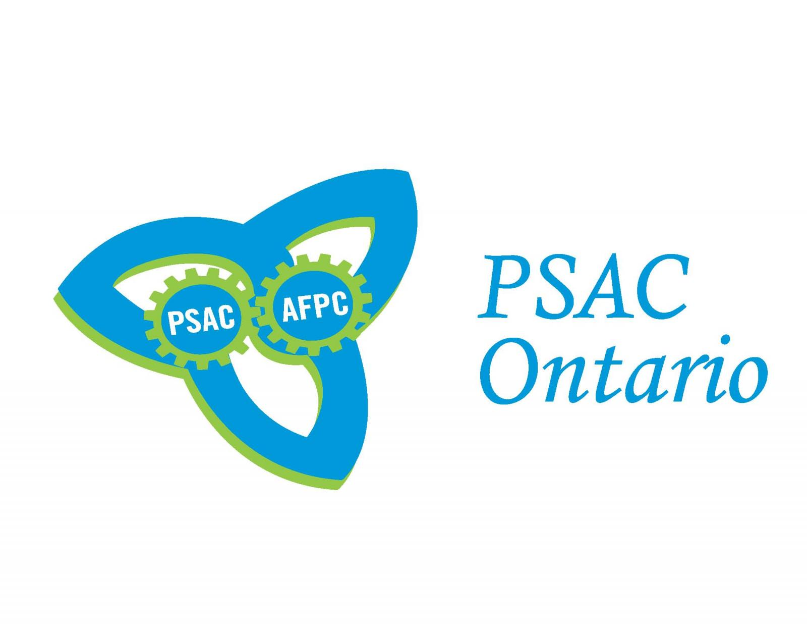



DATES | TIMES | REGISTERBY | Course Title | LOCATION
January 24, 2020 | 6:00 p.m.-9:00 p.m. | January 23rd, 2020 | Lobbying Workshop | North Bay  Timmins
January 25, 2020 | 9:00 a.m.-  5:00 p.m. | January 24th, 2020 | Strike Training Phase II | North Bay  Timmins
January 26, 2020 | 9:00 a.m.–  5:00 p.m. | January 24th, 2020 | Strike Training Phase II | Kirkland Lake
February 1, 2020 | 9:00 a.m.–  5:00 p.m. | January 24th, 2020 | Strike Training Phase II | Sudbury
January 29, 2020 | 10:00 a.m. +  7:00 p.m. | January 28th, 2020 | Lobbying | Webinar
February 29-March 1, 2020 | 9:00 a.m. – 5:00 p.m. | February 24th, 2020 | Talking Union Basics | Sudbury
March 28th, 2020  POSTPONED | 9:00 a.m.- 5:00 p.m. | March 18th, 2020 | Convention Procedures | North Bay  Timmins
April 4-5, 2020  POSTPONED | 9:00 a.m.-  5:00 p.m. | March 25th, 2020 | Talking Union Basics | Sault Ste.Marie
April 25-26, 2020 | 9:00 a.m.-5:00 p.m. | April 15th, 2020 | Introduction for Local Officers’ Training | Sault Ste.Marie

To regis

FTo register for courses, complete the BASIC registration form attached and return it to Sudbury Regional Office by mail, fax to 705-674-8652 or email to Sudbury_RO@psac.com or you can register online at:
http://ontario.psac.com/sudbury-basic-course-online-registration-form-2020

Please visit the PSAC Ontario Education webpage for course descriptions and our Education Policy at: http://ontario.psac.com/our-organization/education-program

IF THERE ARE MORE THAN 25 APPLICANTS, WE WILL PRIORITIZE TO A MAXIMUM OF 25 PARTICIPANTS AND THE REMAINING APPLICANTS WILL BE PUT ON A WAITING LIST

STATEMENT ON HARASSMENT:
Alliance Education courses are harassment-free. We will neither condone nor tolerate behavior
which undermines the full and equal participation of all in union activities.
SCENT-FREE:
To assist members with environmental sensitivities, all course will be scent-free events.

COURSE DESCRIPTIONS
Convention Prep (1 day)
Course Objectives:
At the end of this course, members will be able to:
- know who to draw on for information about convention
- articulate some of their expectations regarding convention attendance
- focus on the content and process of the course
- explain the main purpose of conventions

Open to: All members

Talking Union Basics (TUB) (2 Days)

Introduces members to the PSAC and prepares them for more advanced union education. It provides an historical and structural overview of the union, introduces participants to the collective agreement and gives them a chance for hands-on practice in problem-solving

Open to: All members

Lobbying Workshop (3 hours)

By the end of this activity, participants will develop an understanding of the importance of lobbying as a means of influencing the political system.

Open to: All members

Introduction to Local Officers’ Training (2 days)
Gives Local Officers essential knowledge for upholding their Local responsibilities and building a strong union. Participants learn:
•How an effective Local functions;
•Roles and responsibilities of the Local Executive;
•How Executives can work well as a team, engage members, and
•Deal effectively with management.
This basic course is a prerequisite for the Advanced Local Officers Training.

Strike Training Phase II (1 day)
Course Objective
This training will help members:
- Know the roles of strike participants
- Be prepared to picket effectively
- Anticipate and be able to respond to personal problems they may face
- Be able to conduct an effective strike action
- Be empowered to motivate others know the roles of strike participants

Open to: All members
BASIC COURSE DETAILS

MEMBERS IN GOOD STANDING WHO COMPLETE BASIC WEEK-END COURSES ARE ENTITLED TO THE FOLLOWING:

PER DIEM:

$50.00 per day upon successful completion.

Family care expenses of up to $80 per day for the first dependent and up to $55 per day for every additional dependent. Original receipt and Family Care Allowance Form are required.
What are not covered are family care costs that would have ordinarily been incurred during work hours had the member been at their place of work.

Any member who is scheduled to work on the day(s) of a PSAC educational event will be paid actual Loss of Salary (LOS) - including shift and weekend premium – upon submission of an on-line member expense portal claim. Members are to submit a copy of their shift schedules along with their leave request to their employer, so that the PSAC can issue an Authorized Union Leave letter for their employer. In order to assist us in managing and maximizing our education budget, please contact the PSAC Sudbury Regional Office to discuss any LOS claim prior to the event.

Courses are being offered throughout the region and we encourage members to attend courses that do not require them to be on travel status, which is not reimbursed by the PSAC.

PSAC Ontario Regional Office (RO) Education Travel and Expense Entitlement Policy is available online:
http://ontario.psac.com/sites/ontario/files/uploads/ontario_basic_travel_policy_june_2019.pdf

Members who attend a course which they have already completed with the previous two years are not eligible to receive this per diem.

We thank you for your interest in PSAC Education

