***The next meeting of the***

***Thunder Bay and NW ON Region Area Council***

***will be on***

***Tuesday, February 12th at 5:30***

***Thunder Bay Regional Office***

***224-1139 Alloy Drive***

Agenda items and RSVP’s can be submitted to Tony Crupi, Area Council President at [tbaynwac@gmail.com](mailto:tbaynwac@gmail.com) by 4:30 on February 11th.

PSAC Area Councils are made up of members from different locals and components, grouped within regional areas. Area Councils are the political arm of our Union - they engage with and mobilize around various PSAC campaigns. Members also come together to lobby their political representatives, raise awareness of issues affecting our members, workers and the Canadian public. Area Councils also allow for discussion, collaboration and activism across Component lines. Area Council members also work with community partners, build links with other Labour groups and send members and resolutions to PSAC Regional and National Conventions.

Out of town members are invited to participate by teleconference. Please contact the Thunder Bay Regional Office 1-800-355-0794 to register for the teleconference.

We look forward to seeing you!

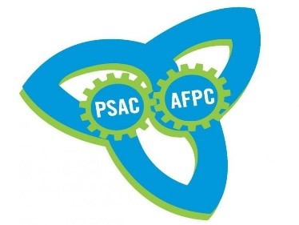 ***Thunder Bay and NW ON Region Area Council***