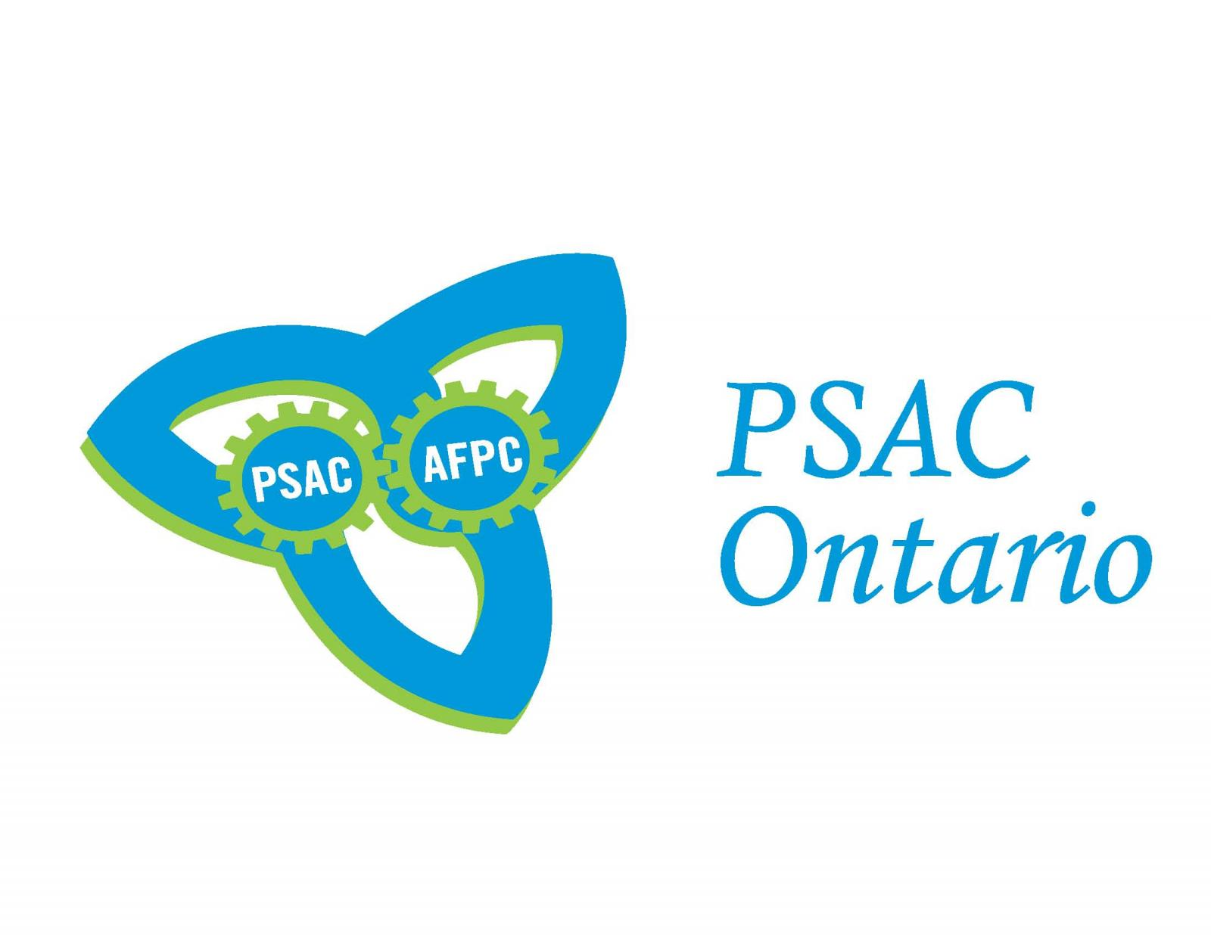

December 5, 2018

Please post on Union Board
DATES | TIMES | REGISTRATION DEADLINE | Course Title | LOCATION
February  23-24 | 9am-4:30pm | February 15th, 2019 | Talking Union Basics | PSAC Thunder Bay Regional Office  224 – 1139 Alloy Drive  Thunder Bay, Ontario P7B 6M8
March  23-24 | 9am-4:30pm | March 15th, 2019 | Grievance Handling | PSAC Thunder Bay Regional Office  224 – 1139 Alloy Drive  Thunder Bay, Ontario P7B 6M8
May  25-26 | 9am-4:30pm | May  15th , 2019 | Respectful Workplace/Anti-Harassment | PSAC Thunder Bay Regional Office  224 – 1139 Alloy Drive  Thunder Bay, Ontario P7B 6M8

IF THERE ARE MORE THAN 25 APPLICANTS, WE WILL PRIORITIZE TO A MAXIMUM OF 25 PARTICIPANTS AND THE REMAINING APPLICANTS WILL BE PUT ON A WAITING LIST

To register for courses, complete the BASIC registration form attached and return it to: Thunder Bay Regional Office by mail, fax to 807-344-0704 or phone 807-345-8442 or 1-800-355-0794
Or you can register online at BASIC:www.psac.com/ontario (Thunder Bay)
http://ontario.psac.com/thunder-bay-basic-course-online-registration-form-2019

BASIC COURSE DETAILS

MEMBERS IN GOOD STANDING WHO COMPLETE BASIC WEEK-END COURSES ARE ENTITLED TO THE FOLLOWING:
Family care expenses in accordance with the PSAC Family Care Policy.

$50.00 per day upon successful completion.
Members who attend a course which they have already completed within the previous two years are not eligible to receive this per diem.
Shift workers who are scheduled to work on the day(s) of a PSAC course is held will be paid loss of salary (including shift and weekend premium) provided they complete a Member Expense Claim Form and submit a copy of their shift schedules.

Courses are being offered through out the region and we encourage members to attend courses that do not require them to be on travel status.

COURSE DESCRIPTION

TALKING UNION BASICS (2 Days)

Talking Union Basics is an introductory, core course that has been designed to introduce members to their union and collective agreement. It has been drafted with the following goals and objectives:

Goals
- have bargaining unit members knowledgeable about their union.
- initiate members’ interest in having their working conditions respected and improved upon in the workplace.
- create a union presence in the workplace.
Objectives
By the end of this course, participants will:
- know why workers need unions,
- understand the basic principles and values of the PSAC,
- know what the PSAC looks like, how it operates, how to participate and who to go to for information and help,
- know their basic rights and how to exercise their rights,
- understand their obligations as union members,
- be able to read, interpret and apply their collective agreement.

Open to: All members

Prerequisite: N/A

GRIEVANCE HANDLING (2 Days)

The major purpose of this course is to provide grievor’s union representatives with basic knowledge and skills to work with members and effectively process grievances at the initial stages of the grievance procedure and to mobilize them around workplace problems.

By the end of the course, participants will:
- Know what a grievance is and where the right to grieve comes from;
- Understand their legal and contractual rights and obligations as union representatives in the grievance process;
- Understand how the grievance process works;
- Know how to write a grievance,
- Be able to fully prepare for a grievance hearing;
- Be able to motivate and involve members in the grievance process;
- Be able to effectively present a grievance to management;
- Be able to prepare a grievance file that can be used at all stages of the grievance process.

Open to: Stewards, Local Executive members, local activists, health and safety committee members, all members

Prerequisite: Talking Union Basics

RESPECTFUL WORKPLACE/ANTI-HARASSMENT (2 Day)
On day one, participants will; look at power relationships and how they affect the workplace, identify ways of effectively working across diversity, identify elements that make up a respectful workplace, discuss what is needed in order to establish and maintain a more respectful workplace, and identify and practice skills and methods for dealing effectively with workplace conflict.
On day two, participants will; define harassment and bullying and the impact they have at work, look at policies, processes and the legal framework that governs harassment in the workplace, identify measures for preventing workplace harassment as well as formal and informal recourse routes, outline the roles and responsibilities of the parties in dealing with workplace harassment, be able to identify when harassment occurs and work through some effective strategies for dealing with workplace harassment when it occurs.

Open to: All members

Prerequisite: Talking Union Basics

PSAC EDUCATION BASIC COURSE REGISTRATION FORM

Application form must be faxed, emailed or sent before deadline to:
224 – 1139 Alloy Drive, Thunder Bay, ON P7B 6M8
Phone: 807-345-8442, Toll Free: 1-800-355-0794
Fax: 807-344-0704, johnson@psac.com or Thunder_Bay_RO@psac.com
PLEASE REGISTER ME FOR THE FOLLOWING COURSE(S):
1. | COURSE
1. | DATE
1. | LOCATION
2. | COURSE
2. | DATE
2. | LOCATION

NAME
COMPONENT/DCL/LOCAL #
POSITION IN LOCAL
HOME ADDRESS
CITY, PROVINCE
POSTAL CODE
HOME TELEPHONE
PERSONAL EMAIL ADDRESS
PSAC ID #
DATE COMPLETED TUB COURSE
(if a pre-requisite)
SPECIAL NEEDS: E.G. Special diet, wheelchair access, sign language, documents in alternate formats etc.
WOULD YOU LIKE TO BE INCLUDED ON OUR EMAIL CONTACT LIST: | YES | NO
All PSAC events, including this course, are smoke and scent free.
Alliance Education courses are harassment-free.
The PSAC is committed to ensuring that the accessibility and dietary requirements of our members are respected.

