**Our PSAC Thunder Bay Regional Women’s Committee and our PSAC Ontario Council’s Aboriginal Representative are hosting a:**

**“Sisters in Spirit Vigil”**

**October 4, 2017**

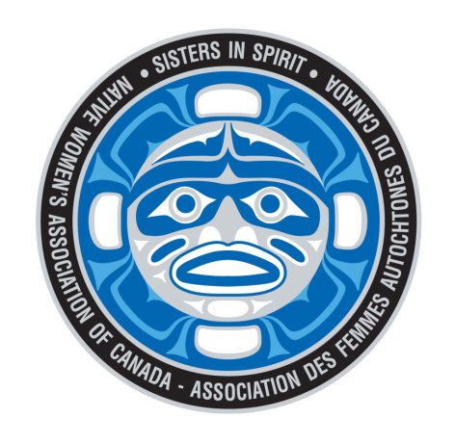

**To honour the Murdered and Missing Indigenous Women and Girls (MMIWG),**

**our Vigil will consist of; smudging, drumming, women’s sharing circle, a moment of silence, and tobacco offerings to the sacred fire!**

**All followed by a Feast!**

**A “Three Sisters” Legend will also be shared with an opportunity for you to make a Corn Husk Doll.**

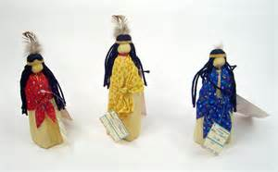

***Since this is an outdoor event,***

***Please remember to bring a lawn chair and to dress accordingly!***

**Event Location & Time:**

**915 Centre Ave, (Two blocks West of James Street, off Mary Street)**

**See you at 5:30 pm**

**Please “RSVP” Nancy Johnson at** [**johnson@psac.com**](mailto:johnson@psac.com) **or by phone @ 807-345-8442**

**by end of business on October 3rd. This will ensure that we have enough food**

**and corn on the cob for our Corn Husk Dolls.**

**If you have allergies, please let us know.**